Course Description
Introduction to health IT standards, health-related data structures, software applications and enterprise architecture in health care and public health. Lab required.

Student Learning Outcomes
- Describe general functions, purposes and benefits of health information systems.
- Describe the evolution and adoption of health information systems.
- Compare health information systems in terms of their ability to support the requirements of a health care enterprise.
- Explain the impact of electronic health records on reporting outcomes.
- Explain strategies to minimize major barriers to the adaption of electronic health records.
- Explain the principles of health care data exchange and standards.
- Review workflow design and assessment, and their relationship to patient care, productivity and data analysis.
- Propose the hardware, software, operating system and networking considerations necessary for effective data storage and use in health care organizations.
- Utilize the tools and techniques for collecting, storing, securing, retrieving, and reporting health care data.

Course Comments

Textbook Information
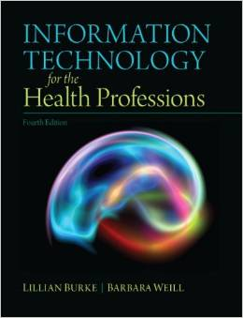
Information Technology for the Health Professions ISBN: 978-0-13-289764-8
Health Information Management Technology with CD ISBN: AB103112
Building a Foundation with Microsoft Office ISBN: 978-1-591364863

