CougarWeb:
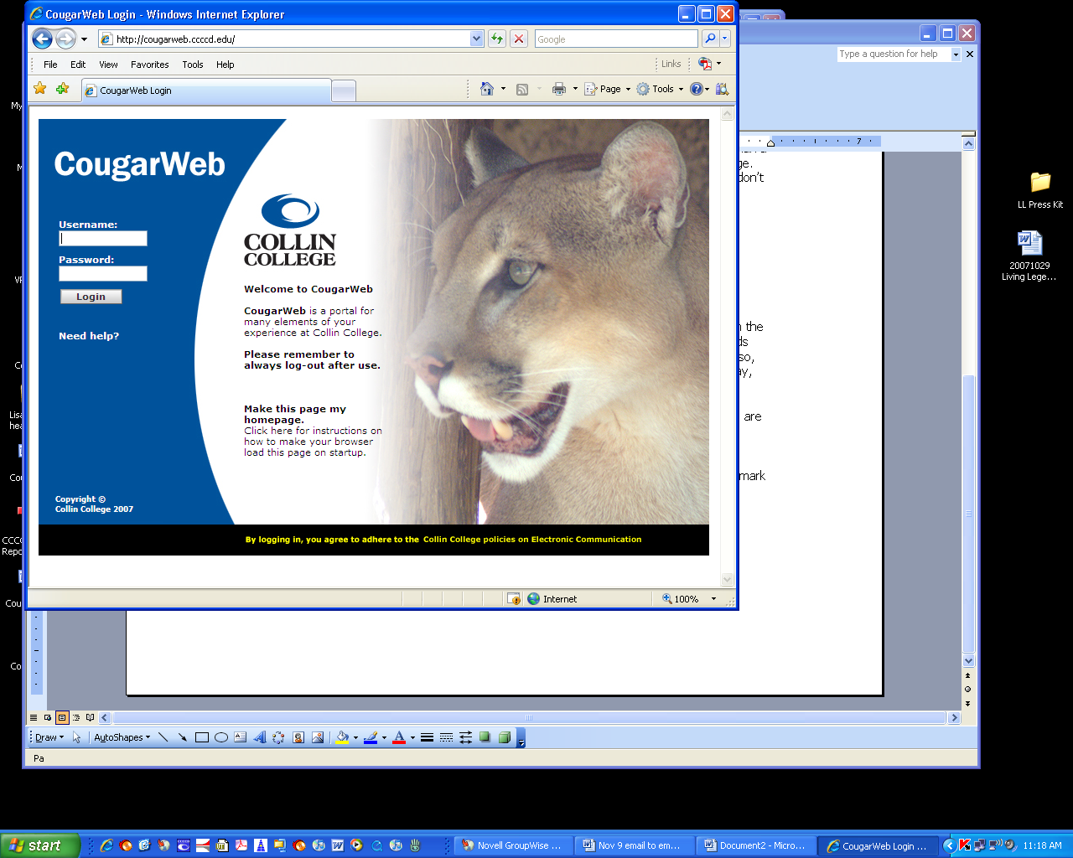
Getting Started

Step 1: Log in
Go to http://cougarweb.ccccd.edu

In the username and password fields,
enter the Novell network username
and password that you use to log into your
computer each day.

Then, click the button.

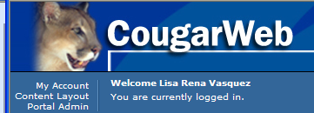
Step 2: Get acquainted.
When you log in, you should see a welcome message with your name, just below the CougarWeb graphic.

CougarWeb is organized on a series of tabs
(like the “Home” tab pictured at right)
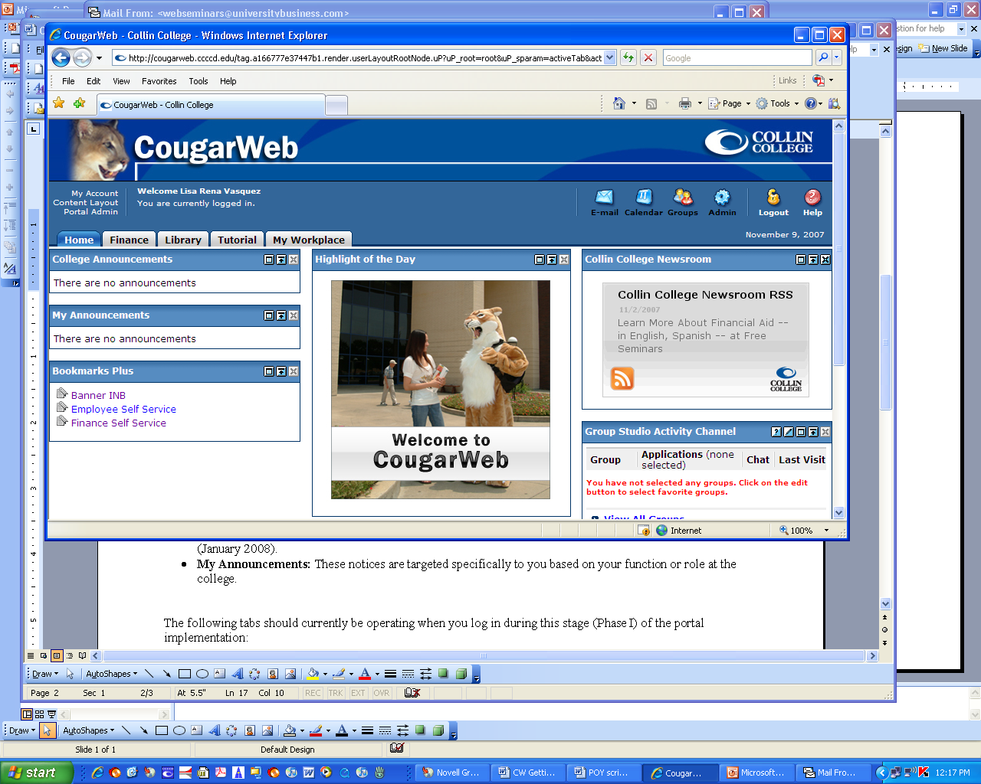
and in the boxes of content that
are called channels.
To navigate through the
portal, click on any of the tabs and
browse through the channels.

Keep in mind that the portal is in pilot status, so some tabs and channels may be under construction as the Banner implementation continues. Below are a few highlights:

Step 3: Logout when you are done.
Click the Logout icon in the upper right corner to end your session in CougarWeb. This is very important!

.

To learn more about minimizing and moving channels or other ways
to customize your view of CougarWeb, stop by the next open lab session
(Dec. 10 or Jan. 4) for a guided tour!

Phase I Highlights
Home Tab
- College Announcements*: The college will post important notices like campus closures or big news in this channel when it needs to reach employees and students throughout the district.
- My Announcements*: These notices are targeted specifically to you based on your function or role at the college.
- Bookmarks: Ultimately, this will be the home for shortcuts to common tools in Banner like admission info, course descriptions, registration, etc. Shortcuts are now live to Internet Native Banner and Finance Self-Service. Employee Self-Service coming soon.
- Highlight of the Day*: Special spotlight for on-campus activities.
- Collin College Newsroom: An RSS feed to the college’s virtual newsroom.
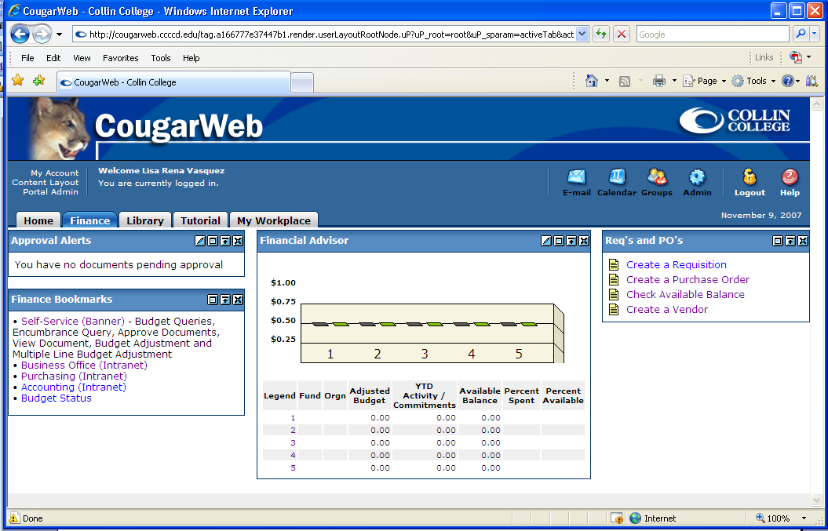
Finance Tab
- Approval Alerts: Notifies cost center managers whenever a requisition is pending approval in Banner.
- Finance Bookmarks: Shortcuts to budget information via Banner Self-Service for Finance as well as helpful Intranet links.
- Financial Advisor: Chart showing expenditures and budget status.

Library Tab: Check out all the LRC resources and databases available without additional passwords!

* This channel will activate in Phase II of the CougarWeb implementation, in January 2008.

