Copying roster into Excel

This method works for faculty who select Course Studio/Luminis Platform for their course homepage. If they use Blackboard, this method will not be accessible.

1. Login to CougarWeb at http://cougarweb.ccccd.edu and log in with the Novell Network ID and password used to access the college network.
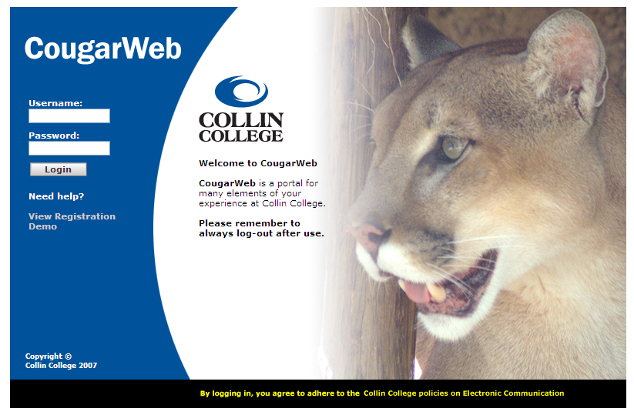

2. Click on Faculty tab. In the MyCourses channel, click on "Click here to:"

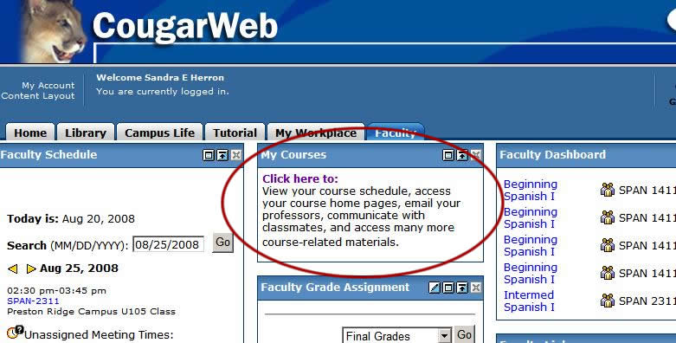

3. Under “Courses I’m Teaching,” click the name of the course.

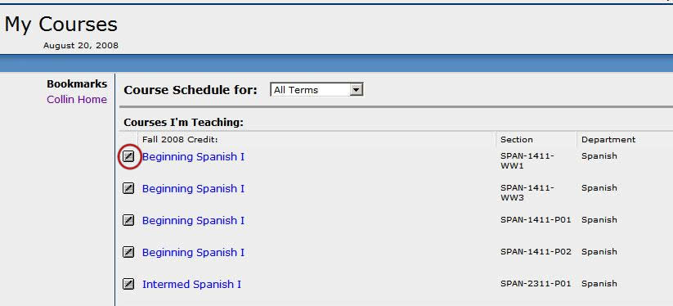

4. On the Course Homepage in the first column on the left, select “Members” in the list of Course Tools.

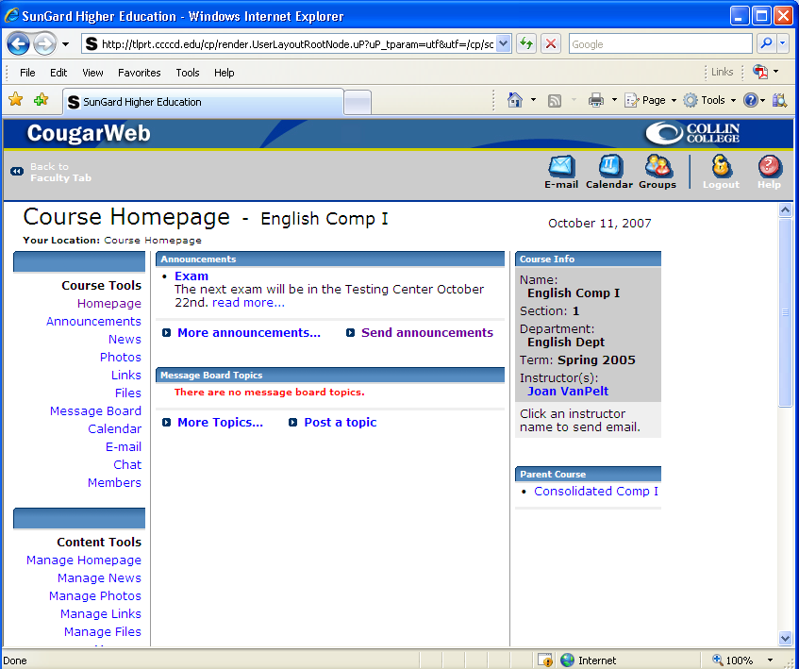

5. In the Class Member list, place your cursor before the first student’s name, then click/hold/drag/scroll through the last name until all class members are selected. Then right-click the mouse and copy.

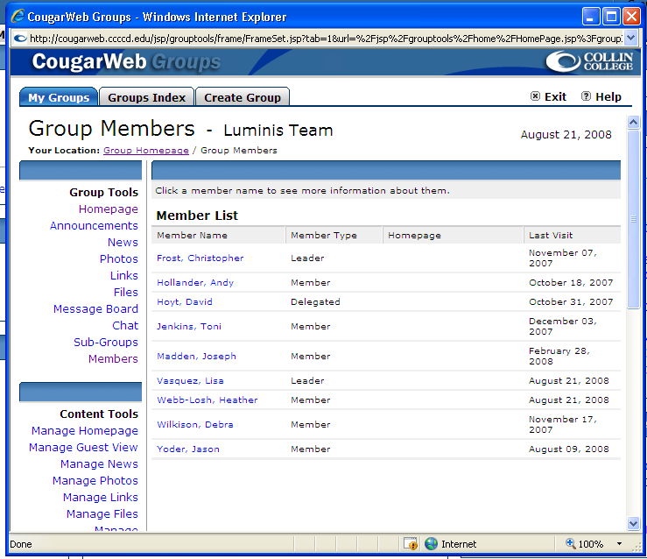

6. Open a blank worksheet in Excel. Click in a blank cell and paste.

This should import 4 columns of data with the student names in the first column. If you do not want the other three columns, they can be deleted.

