Engineering Technology Programs
ESTIMATED COST OF PROGRAMS*
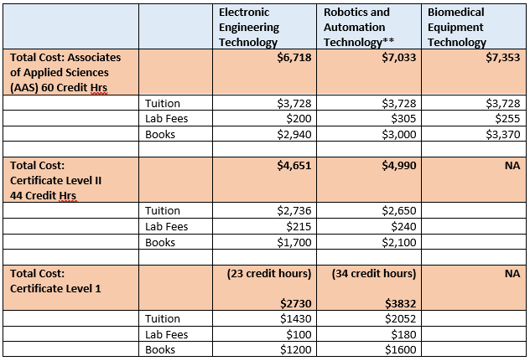

* Estimated cost is for Texas and Collin County Residents only. Tuition, lab fees, and cost of books may change.
**Formerly known as Industrial Automation.

