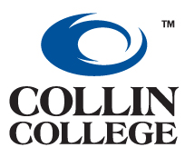
Career Services & Student Employment
2200 West University Drive
McKinney, TX 75071-8001
Metro: (972) 881-5790 Ext. 6747 or 6769
Fax: (972) 881-5639
Email: studentjobs@collin.edu

OFF CAMPUS JOB REQUEST FORM

Date:

Company Name:

Company Services or Products:

Contact Person:

Address:

City: State: Zip Code:

Telephone: Fax Number:

Email Address:

Website Address:

Title of Job to be posted:

Description of Responsibilities:

Special Skills:

Part-Time Full-Time Permanent Temporary

Days Required: Hours Required:

Salary:

Employers preferred application process:

Apply in Person Call for Appointment Fax Resume
Email Resume to:

Are you an Equal Opportunity Employer? Yes No

“THIS IS TO CERTIFY THAT OUR COMPANY HAS A POLICY NOT TO DISCRIMINATE ON THE BASIS OF RACE, COLOR, RELIGION, SEX, NATIONAL ORIGIN, AGE OR HANDICAP AND REQUIRES AFFIRMATIVE ACTION IN ITS EMPLOYMENT POLICIES.”

OFFICIAL SIGNATURE: DATE:
(Typed signature is accepted.)

